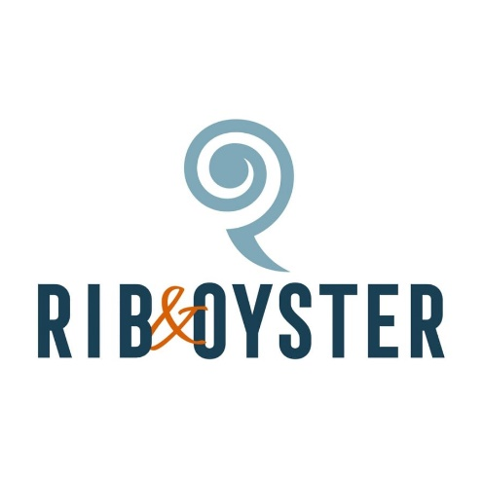
Evening Menu

Starters

Hand dived scallops.
Pan fried scallops with black pudding and chorizo £11.50

Pembrokeshire handpicked oysters.
Atlantic Edge Oysters served cooked or raw (5) £12.50

Pembrokeshire Pork ribs.
Sticky bourbon and bbq pork ribs £7.50

Tiger Prawns.
Tiger prawns (4) poached in garlic and lava bread butter £9

Prices may vary due to seasonal availability
Please inform a member of staff of any allergies, thank you.

Mains
Steak
Served with grilled vine tomatoes & onion fritter.
(GF option available)

Fillet 10oz £30.00
Rib eye 12oz £26.50

Upgrade to surf & turf:
Tiger prawns in garlic butter £7.00
Half Pembrokeshire lobster £20

Pan roasted chicken breast
Stuffed with creamy leeks, topped with a smoked bacon Welsh rarebit £16.00

Fish of the day
Served with either creamy prawn bisque or cherry tomato, caper & dill sauce.
Please enquire for more information

Pembrokeshire lobster
Lazy lobster served either thermidor or garlic butter £45.00

All main courses served with either chips or jacket potato.

Sides

Side salad £2.50
Seasonal vegetables £2.50
Jacket Potato £2.50
Chips £2.50
Garlic bread £3.00
Garlic bread with cheese £3.50
Peppercorn sauce £2.50
Stilton Sauce £2.50

Prices may vary due to seasonal availability

Please inform a member of staff of any allergies, thank you.

